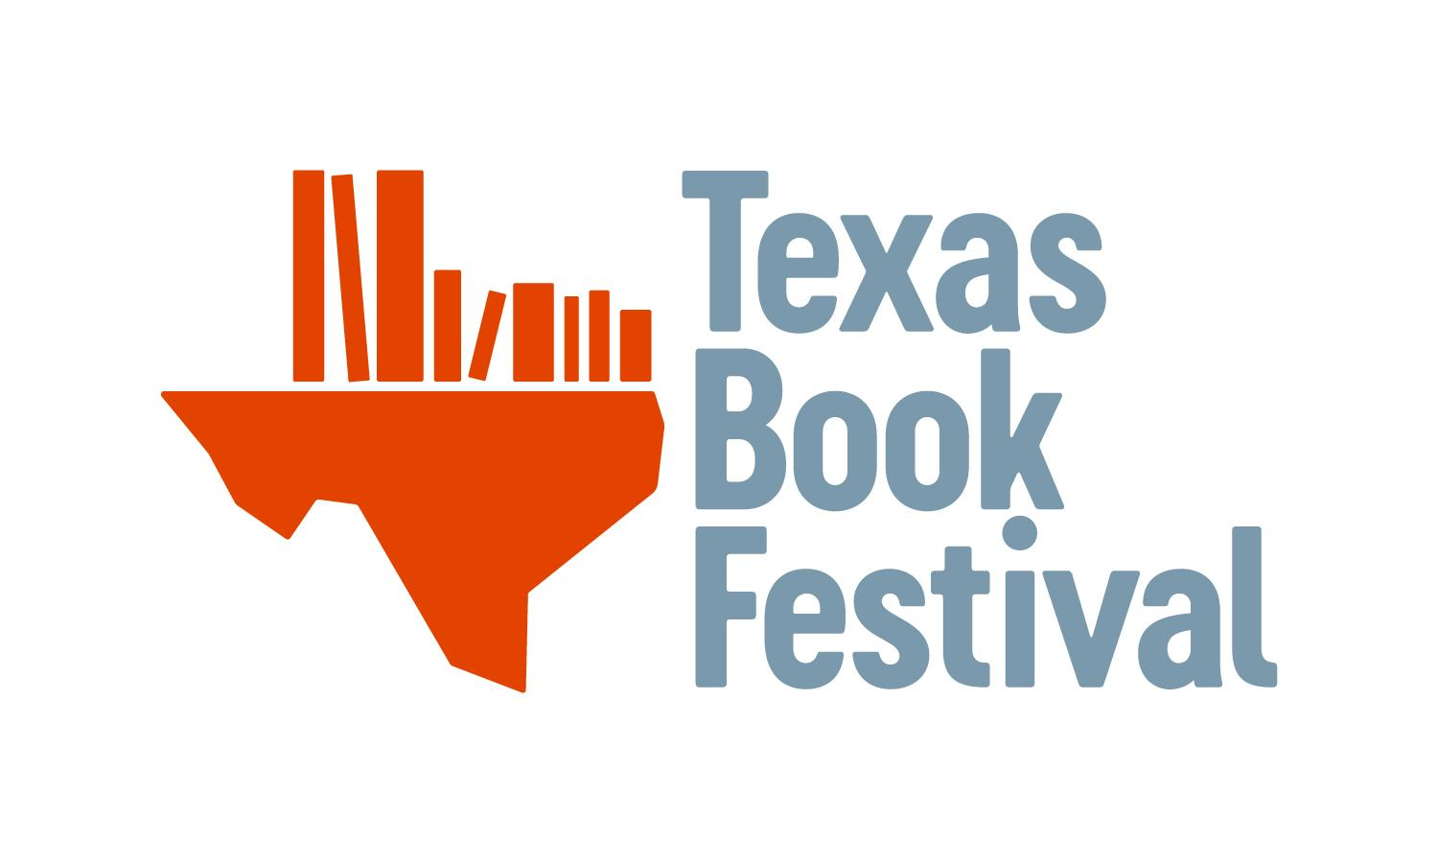

2022 Texas Library Grant Recipient - Final Report

The Final Report must be received via email by March 1, 2023. Libraries not submitting timely and complete reports will be penalized on future applications.

Directions: Please leave the Texas Book Festival Final Report questions in bold. Your answers should be typed into this document using Times New Roman, size 12. Please leave all responses in black. Your Final Report will not be considered complete unless the following items are also received (if possible, please include all items in one email).

- Copies of receipts/proof of purchase
- Photographs to document the new items in circulation

Email all components of the Final Report to Michelle Hernandez: michelle@texasbookfestival.org

Name of Library:
Contact Person:
Telephone:
Email:
TLA District:

- Summarize your project and include any modifications that were made to the original proposal. What did you purchase? Why?
- What need did the grant meet?
- Please provide any anecdotes or stories about the impact the grant has had on your library and community. (These stories or anecdotes should be connected to the photograph(s) that you submit with the final report to be used in Texas Book Festival promotional materials.)
- How many books total did you purchase?
- How many did you originally think you would be able to purchase?
- Did you use the quote/vendor that you provided on your grant application? If not, why?
- In which genre were the majority of the books purchased?
- In which month were the books in the above genre put into circulation?
- In the chart below, please enter circulation numbers in the genre you noted above. If you are unable to provide circulation numbers by genre, please provide total circulation numbers and an explanation. We understand that not all tracking systems can provide reports. Please provide as much data as is readily available to you and your library.

Month | 2021 Circulation | 2022 Circulation | 2023 Circulation
January
February
March |  |  | X
April |  |  | X
May |  |  | X
June |  |  | X
July |  |  | X
August |  |  | X
September |  |  | X
October |  |  | X
November |  |  | X
December |  |  | X

- If circulation did not increase when the new books were added to the collection, please explain why you think that happened.
- Do you track visitors to your library? If so, please provide the circulation patron count in the table below.

Month | 2021 Patron Count | 2022 Patron Count | 2023 Patron Count
January
February
March |  |  | X
April |  |  | X
May |  |  | X
June |  |  | X
July |  |  | X
August |  |  | X
September |  |  | X
October |  |  | X
November |  |  | X
December |  |  | X

- Did visits to your library increase when you purchased the new books? Why or why not?
- Is this your first grant from the Texas Book Festival? If it is not your first grant, please list all years that you have previously received the grant if that information is available to you.

