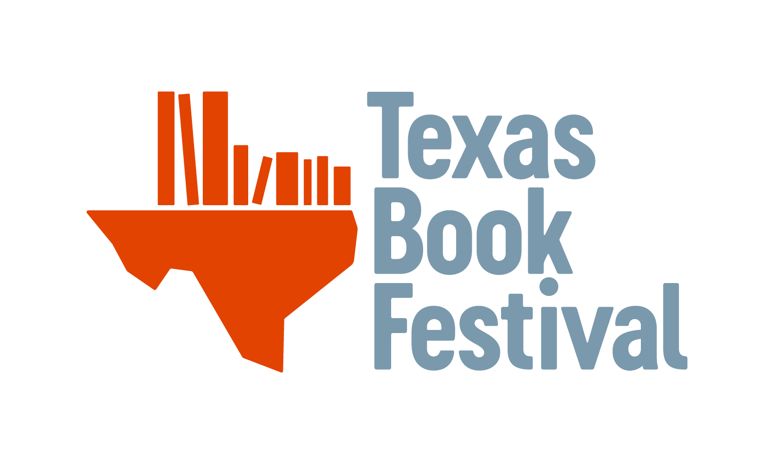

General Instructions for 2020 Grants:
The Texas Book Festival accepts applications from Texas public libraries. Only complete applications will be considered. Libraries which did not submit timely final reports for past grants will not be considered on the current application cycle. All grant applications are reviewed by a committee selected by the Texas Library Association and the Texas Book Festival.

When to Apply:
The Texas Book Festival has one funding period per year for Library Grants. For the 2020 cycle, applications will be accepted with postmarks no later than April 6, 2020.

Where to Apply:
Please mail three (3) copies of each application to:

Texas Book Festival Grants
Texas Library Association
3355 Bee Caves Road, Suite 401
Austin, Texas 78746-6763

Faxed or emailed applications will not be accepted. If you have questions or concerns, please contact the Texas Book Festival at (512) 477-4055 or bookfest@texasbookfestival.org

We fund Collections Enhancements Grants
You can upgrade or increase book collections, e-books, books on CD, and special collections in support of community needs. Test prep, SAT/ACT and reference materials are also included in this grant.
Note About E-Content
E-book subscription services and the individual purchasing of e-books may be funded if the library already has a subscription service and e-readers established. If the library is seeking funding for subscription services and e-books, the library must include details about its current e-readers and subscription services in section 1A of the grant application. As the purpose of the TBF Collection Enhancement grants is to enhance public content through sustainable collections, TBF funds should not be used to initiate e-content subscriptions when no history of ongoing funding is present. The TBF funds can be used to increase demand for e-content supply when the requesting library has a history of sustaining such content through local funding. E-content will be funded for $1,500.

Will NOT be funded:

Videos (VHS or DVD)
Furniture
Gaming Technology
Carpeting
Office Supplies
Televisions or DVD Players
Hardware for Staff Use
Specific “Computers for Tots”

Equipment for Staff Use
Music CDs
Giveaway Books
Marketing Programs
Subscriptions
Textbooks
Kits
Programming materials
Hardware (reformat)
Accelerated readers

Final Report Submission
If an award is granted, it is agreed that the grantee will complete the Texas Book Festival Final Report and submit it no later than December 1, 2020 by e-mail to lucy@texasbookfestival.rog

Grant Writing Tips

1. Fill out the application completely.

2. Complete the application on a computer. Do not do it by hand.

3. Be specific and direct.

4. Be realistic in your request.

5. Make sure you demonstrate need, and how you will fulfill this need with the grant funds.

6. Check your spelling and grammar.

7. Don’t assume that the evaluator is a librarian – refrain from using library terminology.

8. Provide a concise budget and attach quotes from vendors to show what your actual costs will be. Consider using the School Library Journal for average prices if you cannot obtain actual vendor quotes and note why you cannot obtain actual vendor quotes.

9. Provide a timeline of your project, including when you will order items, receive them, implement them, and promote them to your desired community.

10. Provide community statistics to show your need and how the project will address that need.

11. When demonstrating your publicity plan, make sure you are getting outside of your library to reach your audience, promoting the project as well as the Texas Book Festival’s award.

For guidelines, please refer to the General Guidelines section of the application (pages 1-2).

Has this library received a Texas Book Festival Grant in the past? No____ Yes____

Check all that apply: 2010____ 2011____ 2012____ 2013____ 2014____ Other____

District Boundary as listed by TLA: _____________________________________________________________
http://www.txla.org/district-boundaries
Name of library: ___________________________________________________________________

Has this library received a Texas Book Festival Grant in the past? No Yes

If you have received the grant before, in which years (please list)

District Boundary as listed by TLA: ___________________________________________________________
https://txla.org/tla-groups/tla-districts/

Are you a branch library? No Yes

If branch, provide headquarters library: ___________________________________________________
*Please note that we will only award one grant per branch system

Please select the grant that you are applying for. Your stated budget should add up to the selected amount.

I am applying for an e-content grant for $1,500
I am applying for a collections enhancement grant for $2,500

If awarded this grant, check should read: ____________________________________________

Contact Person: _________________________________ Title: ____________________________

Phone: _____________________ Email:________________________________________________

Mailing address (where check should be mailed):

_____________________________________________________________________________________

City: __________________________ Zip:___________________

County: _____________________

Library Director: ________________________Contact Email:____________________________

Information about library:

Number of full-time employees
Number of part-time employees
Current yearly budget
Current materials budget
Average number of books checked out per month

If an award is received, this library agrees to submit a progress report including an accounting of funds by December 1, 2020 to: lucy@texasbookfestival.org

_______________________________________ ____________________________
Signature of Head Librarian Date
Branch library applications must have signature of library director.

Type your responses to the following questions following the suggested word count. Every section of this application must be completed for the application to be reviewed. No attachments will be considered for this portion of the application.

1. Project Description

A. Please state how you will use the Texas Book Festival grant funds to increase or upgrade collections. Suggested word count: 300-500

B. Describe the need or the gaps you have identified in your collection and state how the Texas Book Festival award will be used to meet the need or fill those gaps identified. Please include data to support the need. (For example, if you are requesting books for young readers, please describe the young reader population, the state of your collection, the number of young readers looking for books, etc.) Suggested word count: 300-500

C. Describe who in your community will benefit from this award. Suggested word count: 150-300

3. Proposed BUDGET
A. Give an estimated budget and numbers of books and book-related materials to be purchased with these funds. Funds must add up to the selected grant amount ($1,500 or $2,500) .

Funds may be requested for the purchase of non-traditional book-related items, such as audio-books or e-books for existing e-readers within an e-content grant. TBF grants do not fund videos. Example of how to fill in table is provided below. Please delete the example and input your data. Add to the table as necessary.
Genre | Titles | Quantity | Cost Each | Total Cost
Adult Fiction | Good Book 1 | 3 | 10.00 | 30.00
 | Good Book 2 | 3 | 10.00 | 30.00
 | Good Book 3 | 3 | 10.00 | 30.00
Children’s Non-Fiction | Good Book 1 | 1 | 20.00 | 20.00
 | Good Book 2 | 1 | 20.00 | 20.00
 | Good Book 3 | 1 | 20.00 | 20.00
Audiobook (Fiction) | Good Book 1 | 1 | 15.00 | 15.00
 | TOTAL COST |  |  | $2500

B. Where do you plan to the purchase the books from and why? Suggested word count: 50-200

C. Please attach specific quotes from vendors to support your above estimates (ex. Simon & Schuster, Harper Collins, local bookstore, etc.) as addendums to this application. Please list all attached quotes below. We encourage you to place orders for shelf-ready books but do not require it.

3. Timeline
Provide a brief timeline of how you will use the funds, shelve the books, and market the Texas Book Festival and complete the final report. Please note that we request that the majority of books purchased with TBF funds are shelved by July. Suggested format: table or list

4. PUBLICITY / PROMOTION

A. Below is a list of ways that we ask that libraries promote the Texas Book Festival and the Collection Grant. Please check the items that you are willing and able to do.

Book plates in purchased books
Emails to listserv
Signage in library and town
Instagram
Twitter
Facebook

B. Do you have other ideas on how to spread awareness of the Texas Book Festival in your community? If so, please describe. Suggested word count: 100-300

C. How will you educate your staff and volunteers on the new collection? Suggested word count: 250

